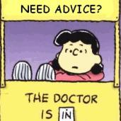
Dan Williams ACTS/MinistryLift Feb 28, 2014
The Small Group Doctor is In
Program Coordinators as Trouble-shooters

A. Why is Small Group Doctoring Important?
- Healthy community is as important as whole individuals

- Jesus spent time and energy as a Great Group Physician (e.g., Mark 9:33f)

- All small groups get into trouble (sometimes because they have done their job well)

- Small group doctoring is at least as complex as soul care

- Preserving or restoring the health of groups is vital the growth of the Body

B. Who is Involved and How Does it Work?
- A concerned party shares (or hints at) the “presenting problem”
Group leader Pastor (general practitioner)
Member >>>>>>>>>>>>>> Program coordinator
Whole group? Coach
Third party?
- Evaluation tools
Informal check-up “How is your small group going?”
Formal check-up Symptom inventory (see Appendix)
- Client contact
Doctor’s office: encourage, and then equip the group leader to do self-care (“community health worker”)
House call: tread carefully; open-ended and non-judgmental; self-prescription is the most motivating
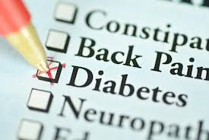
C. Diagnosing and Treating Small Group Pathologies
1. Extend-onitis (the group has outlived itself)

2. Obesity (the group is too big)

3. Honeymoon-itis (the group is too nice)

4. MPD (the group has too many identities)

5. Arrested Development (the group is not growing)

6. Archi-phobia (the group is afraid of leadership)

7. Narcissism (the group is absorbed in itself)

D. Equipping (katartismos) of the System
- Normalize the need for small group doctoring
Build in the expectation to your small group (leader) training
Reinforce the practice in all refresher sessions, group visits, and other communications
Bed side manner: When someone shares a small group problem, don’t look alarmed
- The best medicine is prevention

- Ecological adjustment
